**Advanced Mathematics**

Lab 10

Yu-Hao Chiang 3443130

**Exercise 1 – Exploring Data**

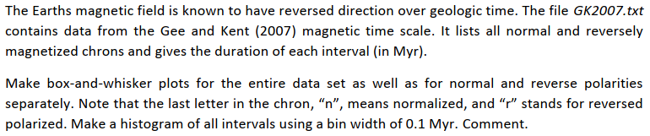

As we seen in the following figure, in order to find the range of box-and-whisker we computed the range between $M-2.698σ ≤data≤M+2.698σ$. By doing this, we can ensure that 99.3% od data are in the confidence interval.

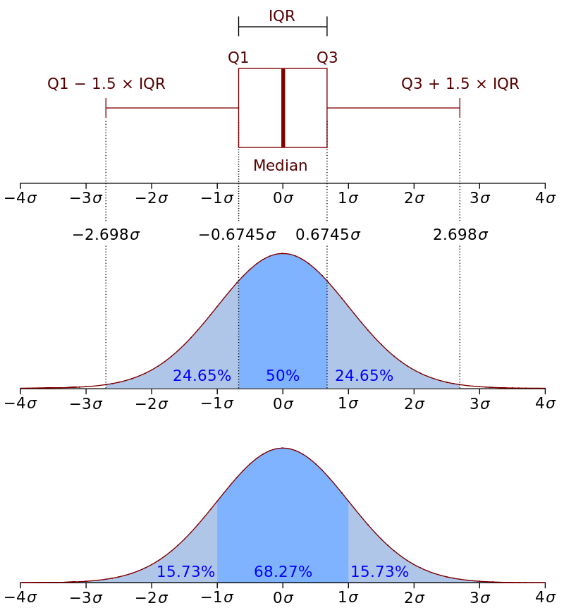

Figure 1 Boxplot and a probability density function (pdf) of a Normal N(0,1σ2) Population

At figure 2, we can demonstrate that most of the numbers of polarities gather between 0 and 1 Myr, just only a few numbers outside of this range. It also represents the data’s distribution.

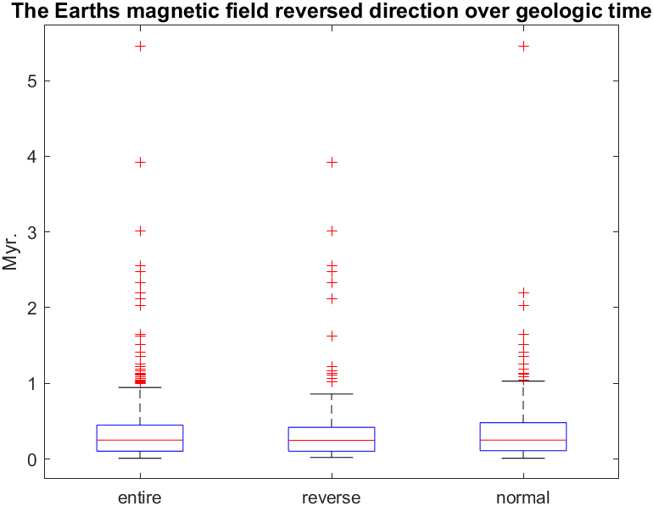

Figure 2 Boxplot of entire, reverse, normal polarities

According to figure 3, histograms convey an accurate impression of the data distribution, so we can assume that around a period of 0.1 Myr, normalized and reversed polarized occur. However, due to some physical reasons the period might increase or even longer. We only can ensure the distribution of the polarized happen, but we can’t connect the relation between each period.

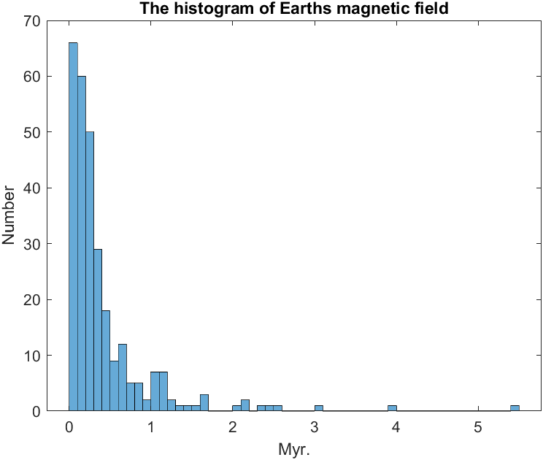

Figure 3 the histogram of Earth magnetic field

**Exercise 2 – Error Analysis**

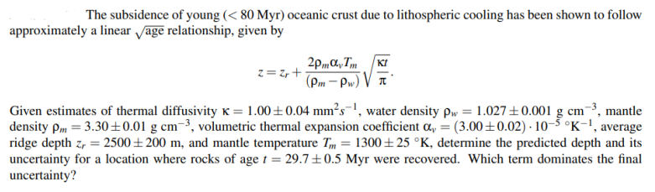

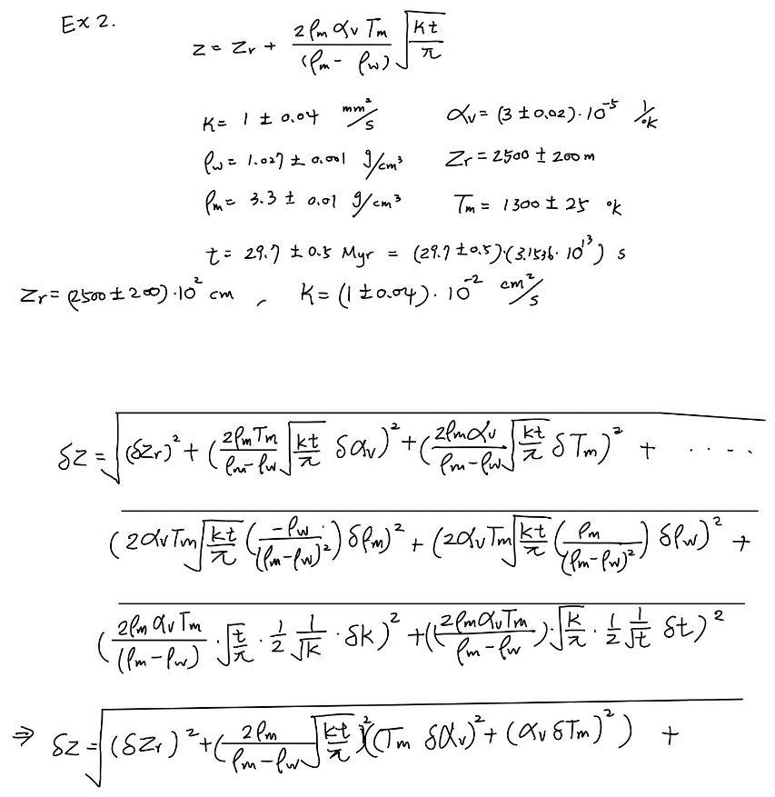

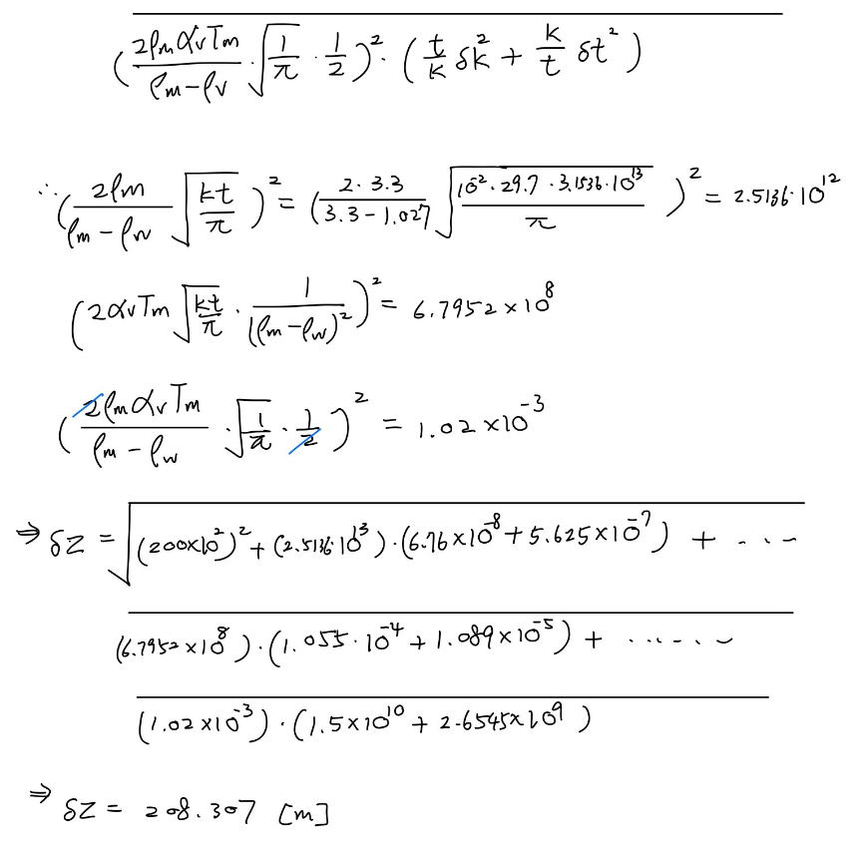

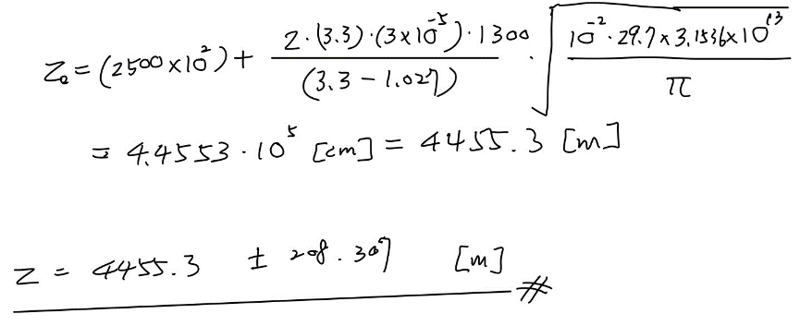

**Exercise 3 – Least square method**

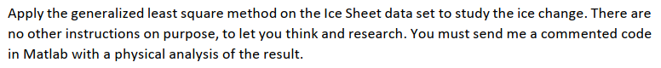

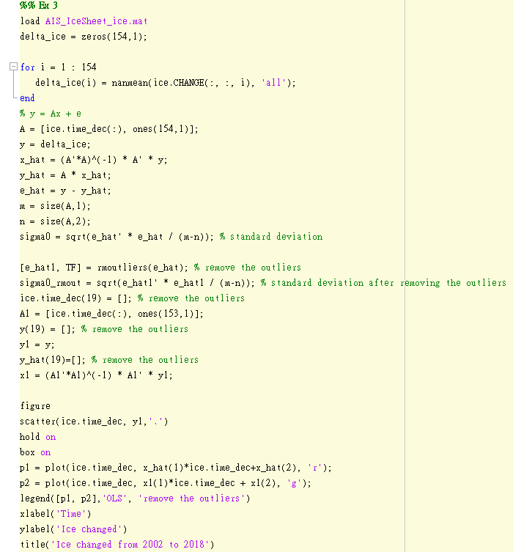

First, I set up the linear regression $ice changed=aT+b$. Then, create adjustment with observation equations $y=Ax+e$.

$$y= {\left[\begin{matrix}Δice_{1} \\ ⋮ \\ Δice_{154}\end{matrix}\right]}_{154×1}$$

$$diff\left(aT, a\right)=T$$

$$diff\left(b, b\right)=1$$

$$A= {\left[\begin{matrix}T_{1} & 1 \\ ⋮ & ⋮ \\ T_{154} & 1\end{matrix}\right]}_{154×2}$$

$x= {\left[\begin{matrix}a \\ b\end{matrix}\right]}_{2×1}$ $(we need to find out a and b)$

$$\hat{x}={\left(A^{T}A\right)}^{-1}*A^{T}y$$

$$\hat{y}=y-A\hat{x}$$

$$\hat{e}=y-\hat{y}$$

$$m=154 (number of unknown)$$

$$n=2 \left(number of observation\right)$$

$$σ_{0}=\sqrt{\frac{{\hat{e}}^{T}* \hat{e}}{m-n}} =11.1758$$

$$x= {\left[\begin{matrix}a \\ b\end{matrix}\right]}_{2×1}= {\left[\begin{matrix}-7.9221 \\ 1.5912*{10}^{4}\end{matrix}\right]}_{2×1}$$

In order to make the linear regression more precision, we can take off the outliers then adjust again. We can see that after skip the outliers the standard deviation became lower, which means the linear regression is more represented the trend of the ice changed.

$$σ_{0}=\sqrt{\frac{{\hat{e}}^{T}* \hat{e}}{m-n}} =10.7635$$

$$x= {\left[\begin{matrix}a \\ b\end{matrix}\right]}_{2×1}= {\left[\begin{matrix}-7.8444 \\ 1.5756*{10}^{4}\end{matrix}\right]}_{2×1}$$

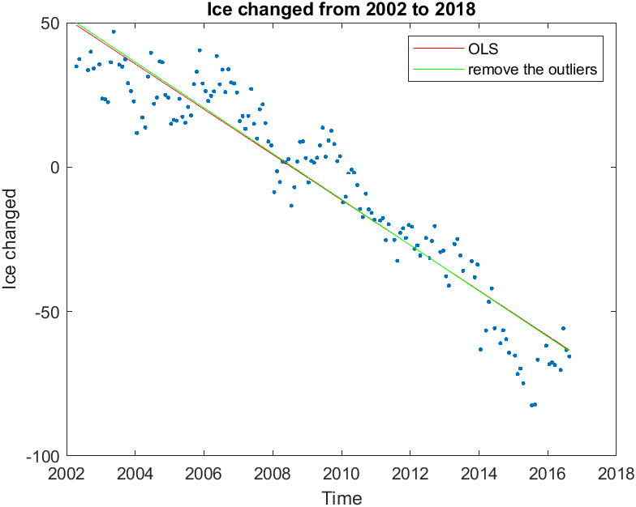

Figure 4 Ice changed from 2002 to 2008

This picture shows that as time changes, the change in the ice layer also decreases (melts). Between 2002 and 2006, the ice layer was still growing (only slowly beginning to grow negatively). Until 2008, the ice layer almost fell in a melting trend. In 2016, the ice has melted 50 meters, which means that the sea level will gradually rise, and the consequences will be unimaginable.